Emai sending Process:

- Start Wampp server.
- Goto following url:http://localhost/iaacpommo/index.php and login with admin details.

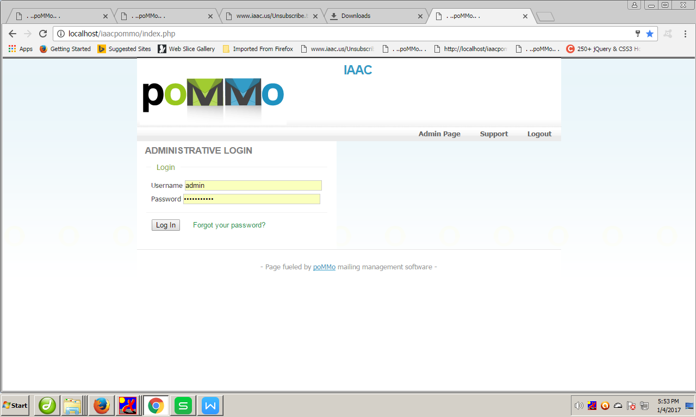

- Select Mailings=> Send

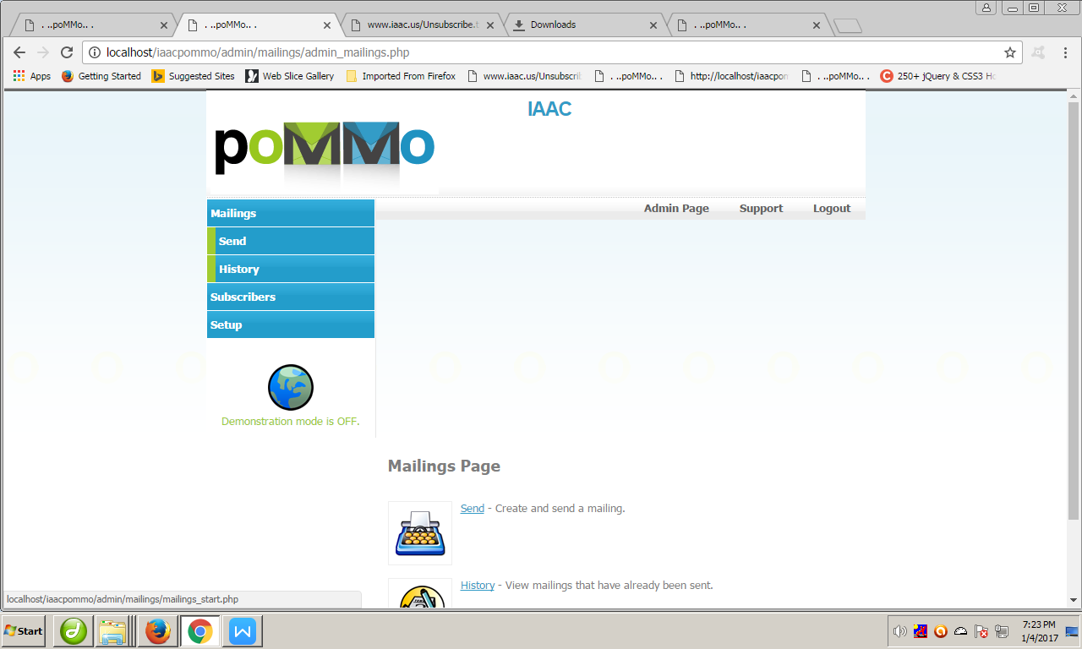

After Setup window will appear like:

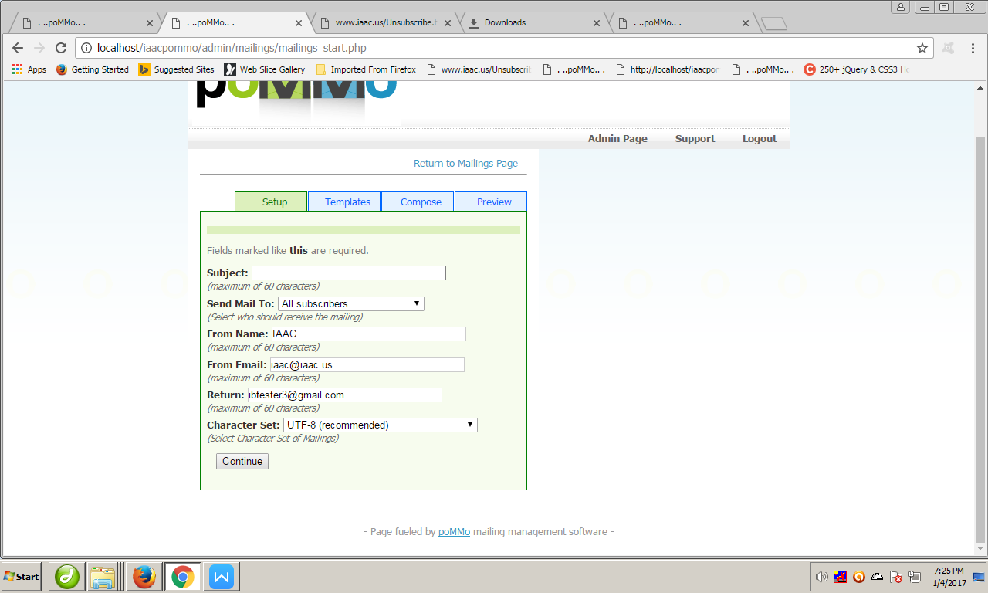

- Setup Tab
Put titile of draft(html page) in above subject box
Select emails group and continue.

- Templete Tab
Skip all fields and continue

- Compose Tab
In html Message filed (put all html code & check web path of every images and links).
- Preview Tab
First Send test mail to yourself then send mail.

Using Click System:

- Configure Files on web server
- Upload configured files and list
- Goto to http://www.iaac.us/follbackfolder/recover1/SendMassMail.php

From: iaac@iaac.us
Subject: title of attachment page;

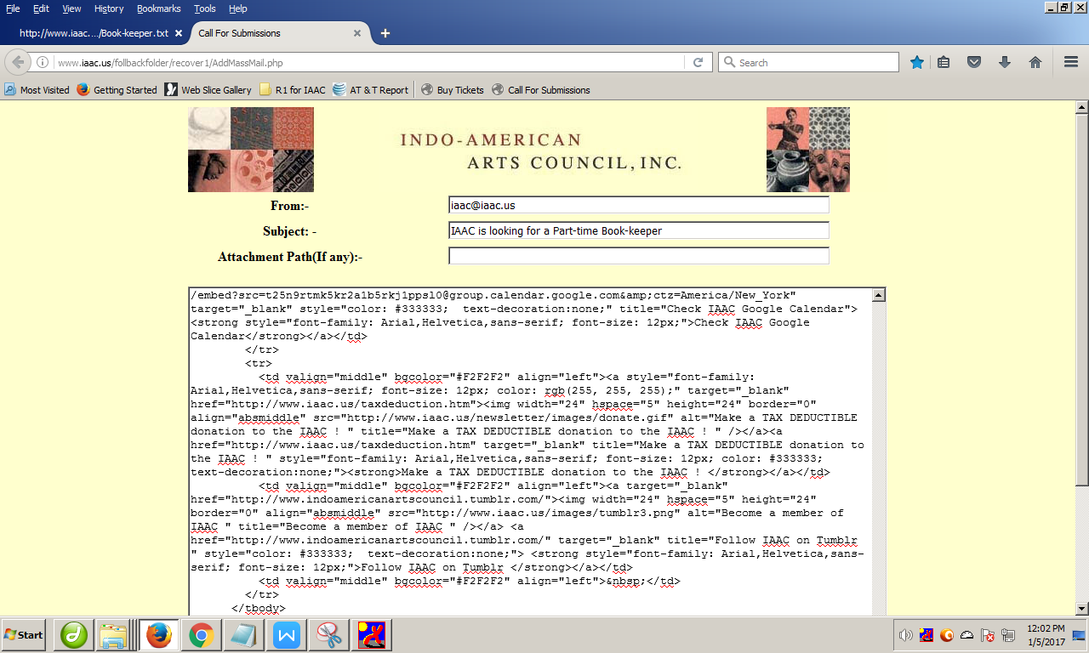

- First enter your email id into list for testing.
- Priview email.
- Send wait for few secod. Dont turn off pc/browser.

